|  |  |
| --- | --- |
|  | Web WhatsApp Status Interaction  Sessional Report  *Course: Human Computer Interaction*  *Lecturer: Sir Anwar Ali Sathio\**  *Submitted by: Uzaif Ahmed\** |
| *7th Semester , BSIT Sec: ‘B’ , Batch: 4th , Registration No. 305* | |
| *Information Technology Department, BBSUL, Sindh, Pakistan* | |

*Submission Date: 4st July, 2021*

**Abstract:** The main aim of this study is on improving the UI and functionality of the Web WhatsApp. We're working on WhatsApp Web's status feature. WhatsApp is the most widely used mobile communication app. Furthermore, WhatsApp on the web is a widely used tool that enables you to use the WhatsApp Application and chat on your computer through synch with the mobile app. The primary problem is that the status viewed by contacts is not accessible on Web WhatsApp, excluding the number of contacts who viewed the status. In this proposed change, the interaction is quite straightforward and sensible, where the user clicks on the eye icon and a little frame pops with the names of contacts and the time when they saw the status. In the top right corner of that small frame, there will be a delete and a share button, one for each status. This would be identical to the Android WhatsApp app's actions and interpretation. Because we're working on an issue with the UI and functioning of WhatsApp Web statuses, our challenge is very tied closely to Human Computer Interaction. While this platform can function in web browsers, the main source of contact will be through Desktops and laptops. The responses for our WhatsApp Web statuses research will appear after the A/B testing or deployment process. We'll see how the public reacts to the modifications we've proposed as in WhatsApp Web. On desktop computers, users will find it easier to modify their status, see the views, delete, and share their status. Anyway, this research project would help to eliminate the constraints of Web WhatsApp and provide the same functionality as that in the mobile application.

**Keywords:** WhatsApp Web Interaction, WhatsApp Web, WhatsApp Status, Status Information, Viewed Status, Status Interface Enhancement,

1. **Introduction**
2. **Defining Problem Statement In HCI Scope:**

The core problem is that the status viewed by contacts is not accessible on Web WhatsApp, except for the number of contacts who viewed the status. According to the HCI scope, certain flaws in the WhatsApp mobile app have been detected. Users are familiar with the ability to remove, share, and see the contact info of someone who has saw the status. The goal of this study is to find a way to compensate for the lack of these characteristics.



**Figure 1.** WhatsApp status panel image

1. **Background of the selected problem’s design:**

WhatsApp is a most commonly used communication channel via Smartphone. WhatsApp has developed an application to provide facility to the users where they can chat, audio and video call, update status and now it also has a desktop version. Moreover WhatsApp on the web is a ubiquitous program that allows you to utilize the WhatsApp messenger on your computer via synchronization with mobile app. To connect on web-WhatsApp, users must scan the QR code which appears when they launch the WhatsApp online application.

1. **Aims & Objectives of the study & its background**

In this research, our main focus is the enhancement in the UI and functionality of the Web WhatsApp. We are focused towards the status feature of WhatsApp Web. The aim and objective is to add the Status Views Tab on each of the uploaded status. Moreover, it should also facilitate in Status sharing and deletion from the same tab. This would resemble the actions and interpretation of the Android WhatsApp application. It follows the User-Centered design approach as the proper A/B testing shall be conducted to make sure that the users adopt the changes in the WhatsApp web.

1. **Scope and Limitations:**

As the WhatsApp application is used worldwide, it is obvious that there are worldwide users for the WhatsApp Web as well. The scope of our problem refers to all the worldwide users of WhatsApp web. Normally the researches have limitations but here we are working on the improvement and there is no limitation. Perhaps, this research paper leads to erase the limitations from the web-WhatsApp and complete the usability as a mobile app provides.

1. **Literature Review**

The problem that we have worked on is on the UI design and functionality amendment in the interface and usability of the WhatsApp Web. If we see previously, there is no such problem that has been raised. However, the work that had been done related to the HCI of the WhatsApp interface is about the usability regarding online activities and the effects of the application on the human life. Our problem is very closely related to the Human Computer Interaction as we are solving an issue related to the UI as well as the functionality of the WhatsApp Web statuses. As we need to add up some design features, the problem stands sturdy over the principles of HCI.

1. **Design and Methodologies**
2. **Design principles and its justification in the problem design**
3. **Familiarities with similar design/devices:**

As we know that the WhatsApp web works similarly as the Mobile Application, so there is a great resemblance between both of the interfaces. Our problem focuses on the WhatsApp web status portion and we want it to be executed just like it does in the WhatsApp mobile application. So there is a familiar design that we need.

1. **Affordances**

Yet another part of this problem is the design affordance. For our WhatsApp web status and UI amendment, there shall be the both types of affordances, the real-world affordance as well as the perceived affordance. As per our problem, the real-world affordance refers to the changing in the actual UI of the WhatsApp web in the status problem, whereas the perceived affordance is all about the User Experience. This would depend on how user accepts our design and the multiple testing techniques before the deployment of our advancements could help us to know how our user perceives the design and gives response as per his experience.

1. **GUI Affordances**

In our focused problem, the GUI affordance puts light on the user interface of the WhatsApp web status tab. Here we need to add some functionalities and for those new functionalities, there is also an addition in the features of GUI. We need to show each of the statuses that user has put on his profile, and under it, there shall be number of status viewers count. As we click on each of the status view counts, there shall be a small window that would show the list of the viewers. Furthermore, there would also be two options on the top-right corner of this small window for deleting that particular status, and sharing it with anyone in the contacts. Here is the GUI affordance that we have discussed:

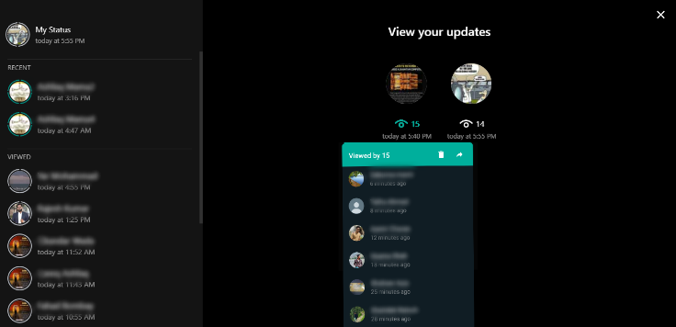

**Figure 2.** 15 viewers of Status 1

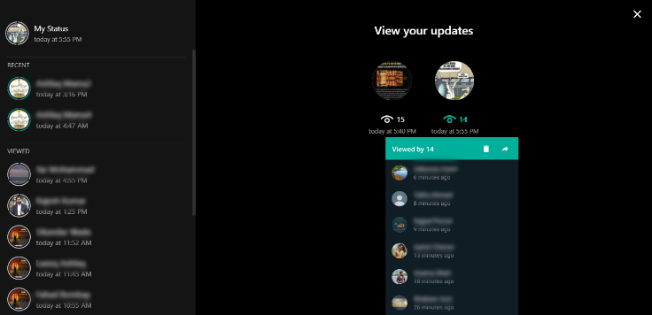

**Figure 3.** 14 viewers of Status 2

1. **Labels**

What we click on to perform an action includes in the labels. In our recommended changings, there are some labels as well. As we have status window showing individual statuses and their view counts, we could click on these view counts to see the status viewers. So this is our first label. Secondly, in the status viewers list window, there are two different labels (a bin, and an arrow). They refer to the deleting and sharing of the status, respectively.

1. **Mappings**

Where there are labels and design, there is the concept of mapping. Mapping implies that where to fix the icons and labels to appear for the GUI affordance. In our proposed problem, we have discussed before that we have labels and icons. In addition, we can click on every status that we have uploaded. So, for the mappings, it has been suggested to use the right sided portion of the WhatsApp web window. Here we shall have all the statuses uploaded in the form of left to right sequence, each of them has the viewers count just below them. Clicking on the count shall drop down a small window under that particular status and there would also be scroll bar on the side of that small window to see all of the viewers. Moreover, the icons for deletion and sharing should be mapped on the upper right corner of the viewers small window. This was all about how the labels and icons in our idea shall be mapped.

1. **Instructions**

Instructions are necessary for the end-user to adopt the design changes. Here in the amended features that we have put forward are depicting the instructions itself. For example if we see the icon of a bin, it simply refers to the deletion of some file or a chunk of data. So, these instructions depend on the GUI affordance that we are up to focus. However, there would be an effect of instruction in the views count of statuses. This would let the users know that how many viewers shall appear as he clicks on the count. Besides all of these, we can also come up with a short guide to instruct our end-users about the advancement in the phase of deployment as well as testing.

1. **Constraints**

There are four types of constraints in design that we are up to focus in our problem. The Physical constraint in our proposed design is about the budget for our design. There would be changing in the famous application's web interface, so the access to this deployment shall be allowed to the developer of WhatsApp Web. This constraint shall be fulfilled by the Facebook Company itself. Semantic constraint may occur if we are unable to control the functionality of the added feature, and in our problem, it is an advancement or addition, so there would be a less chance that semantic constraint may occur. As we know that the WhatsApp web is the worldwide application used by the people without any cultural limitations, so there isn't any exception that could harm the cultural values according to our design. We know that in our problem, there are simple logics to open a viewers window, to delete the status, and to share the status, so there is a less chance of Logical constraint too. However, any human error can make this constraint appear, otherwise, the concept and methodology is free of this constraint.

1. **Interacting with devices**

We are working on the problem related to the WhatsApp Web. It is clear that this website can be executed by anyone across the world as it is a public platform for messaging. For the interaction with several devices, we already know that the WhatsApp Web runs in the Web Browser. These web browsers like google chrome, Mozilla Firefox, Opera, etc. are compatible to run the WhatsApp Web. It can be said that for the system's interaction with the devices, there is a need of a middleware, i.e. the web browser. As this platform could run in web browsers, so the main interaction shall be the device on which we are running the WhatsApp Web. These main devices that can open WhatsApp Web interface with the help of browsers are none other than the PCs, and Laptops. However, the faster the internet, the good and fluent shall be the interaction of the WhatsApp Web interface.

1. **Casualties**

Causalities are of two types, Apparent Causality, and False Causality. It refers to that event which occurs unfortunately. As Causality is a natural phenomenon, and we are here to solve a problem related to technology, there is no chance of any causality. In case when using We WhatsApp, the internet disconnects, then this could cause an Invisible causality. Besides, there is no chance of any causality to occur.

1. **Errors**

Errors are of two types, Slip and Mistake. Slip refers to the event when something happens unfortunately, not planned to do so. Whereas, a mistake is something that happens as per planned actions. We carry out such actions or decisions, that lead to the problem to raise and thus, mistake occurs as a result. In our research issue, we have no such chance of an error, but a mistake may occur if our proposed model would not be understood by the developers of WhatsApp web and they might make problem in the code.

1. **Feedback**

Feedback is the process for checking how much our work runs sufficient in the market. For our research on WhatsApp Web statuses, the feedback shall come over after the A/B testing or deployment process. We shall see how public responds to the changes that we have suggested in the WhatsApp Web. We can also consider this segment as the analysis of our research. After this phase, we shall come to know if the changes are valid for the final amendment or not. According to us, these changes that we have proposed are genuinely valid and we hope for a positive feedback from the users.

1. **Mental modeling importance in the real world**

Mental modeling refers to the thinking of human. In the case of HCI, it is the thinking of human about some devices in order to interact with them. What the user thinks about the design and interactions of the design. It also reflects the user needs that are to be fulfilled by the design. Mental modeling in our research is about WhatsApp Web statuses. Since, the public is using the WhatsApp Mobile Application frequently, they have a good experience of status portion where they can see their statuses and also the viewers of their statuses. This functionality shall be introduced in the WhatsApp Web so that people could experience this on PC and laptops too. Now, as the concept behind our design is highly related to that of WhatsApp Web application and people are familiar to that interface, so making changes in WhatsApp web interface in the status portion shall work out perfectly. We are almost up to resemble the interface of WhatsApp mobile application so that it work out in a good way.

1. **User-Centered Design**

WhatsApp itself has a user-centered mobile based application where user’s choice is judged for approval of any improvement and same as it is we will be implemented it in our Idea. This will be defiantly checked either the status contacts has ability to be shown on web WhatsApp, can it delete and share the status. Either the user like the padding and designing and it is then easier for him to control his Status section. Does it really works well and performing the functionalities dynamically. Now is our stated problem, the user- centered design refers to the User Experience to run WhatsApp web’s status section. We have put forward such an idea which fulfils all the necessities that a user should experience while using the mentioned section. As in our design, we have pushed the “Your status here” tab at the top of the right frame and below that, there is each and every status that the user uploads. Whereas each of the status shall have its individual option to be shared or deleted.

1. **Goal-Oriented Interaction Design**

It has completely goal-oriented design where the user can view the status from top to bottom where each Status will be having separate button for deletion and sharing the status. Another goal is to check the views of all the statuses. The interaction is very simple and logical where to explore the viewers of status the user will click on the eye icon and a small frame will toggle which will show the names of contacts and time when they viewed. That small frame will also include a delete button as well as share button; separately for each status.

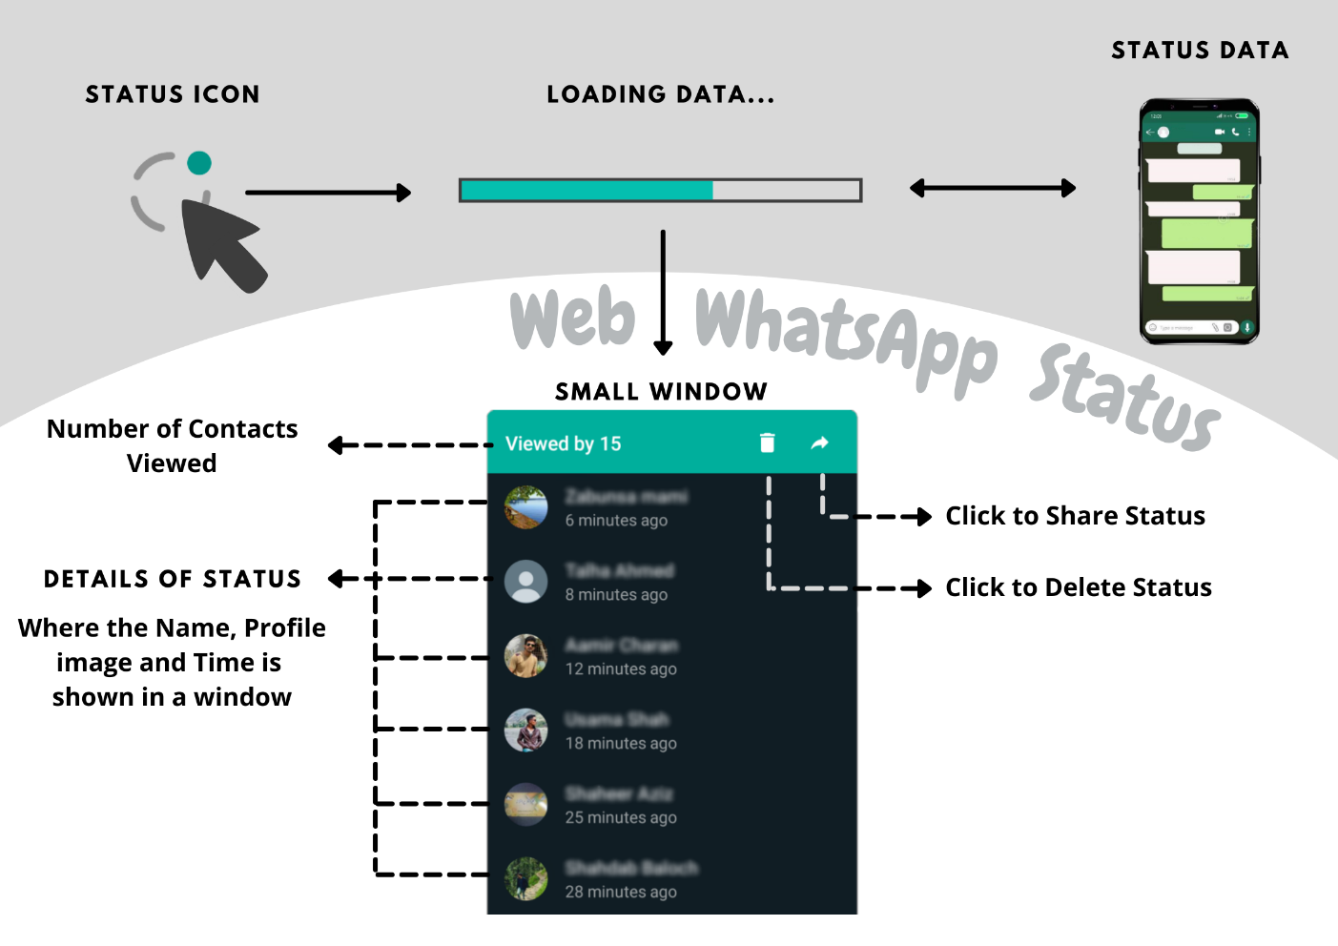

**Figure 4.** Working process can be seen

1. **Goal-Oriented Interface Design**

The main goal of the design regarding the interface is to show all of the statuses that we put in, the buttons that allow deletion and sharing, viewers of out statuses, window which displays these viewers, a scroll panel on the side of the small window, and dark theme color scheme. These goals shall be designed through the developing tools and coding languages of the web WhatsApp. Actually, our work is on amendment, so, there would be editing in the code for our goal oriented interface design.

1. **Interaction Design versus Interface Design:**

Interface design suggests an interface where all of the statuses that we put in, the buttons that allow deletion and sharing, viewers of out statuses, window which displays these viewers, a scroll panel on the side of the small window, and dark theme color scheme. Interaction design refers to the functionality of deleting, sharing and checking views. These functionalities will be loaded on clicking the status button of the home page, and each data will be fetched to display it as it is on mobile. Firstly the viewers of status will be feeded in small window. Secondly, delete button will remove the status from everywhere and last share button will share it the status which will be send via web WhatsApp.

1. **Conceptual Model and Justification**

The Conceptual Model is a small frame that is designed to display the contact and its time when he viewed the status and delete or share that status. Thus, this is already working in the mobile phone and people are well aware about its working but it is not functioning in the web based Whatsapp so that the user can keep his mobile phone connected at a side and use it totally on the web. It seems that users will perceive it that it will display the status of only one status but real concept is that each status will have its separate window which will appear on clicking the eye icon of that status; the eye icon will shine in the standard vivid cyan color of WhatsApp. The constraint is that window will only display the latest six viewers and to look other previous viewers the user would need to scroll it but still only six contacts at a time will be displayed. Justification of the words will be same as standard we see on mobile.

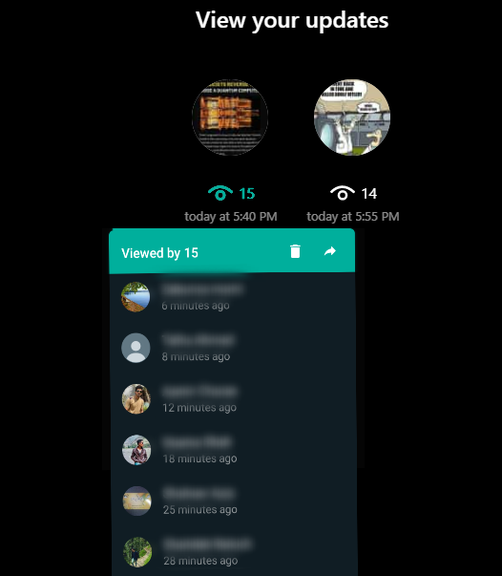

**Figure 5.** Conceptual model and justification

1. **Usability Engineering model**

The proper A/B testing shall be conducted to make sure that the users feel completeness and accuracy in the WhatsApp web. To find efficiency we shall take feedback is the process for checking how much our work runs sufficient in the market. For our research on WhatsApp Web statuses, the feedback shall come over after the A/B testing or deployment process. The users psyche will be judged as per their using behavior and then the Satisfaction will be declared until that we shall be keep working towards the positive attitude.

1. **Six Usability Attributes**

The design is complete with which users can easily delete and share status as well as can see the viewers. It is easy to learn as, it is same as the users have experienced in smartphone and even a novice user can understand it in the wink of an eye. The Status will be in ready-state on clicking the status icon, complete data will be fetched and available at the status panel. The reason of this report is the suggestion for ease of using functionalities of status system immediately for users. No Errors shall be seen accept if the Internet disconnection takes place from any of both devices (Mobile or the Desktop). A popup message shall be interrupted to ask user either he appreciates this feature on web WhatsApp “Yes” or “No”. Either Funnel test can be conducted to find at which point the user is not satisfied.

1. **Design dimensions**

Something which is inappropriate, is the lack of status information, delete and share function, which we have introduced. These are the useful tools for a user to check the information while working on a PC or a laptop where the user would not need to touch his phone again and again to check the update. It is usable for one to have these features on a single device where he can see and manage his status. This feature is simply adopted from its mobile app feature. Developing it appropriately would might be challenging but it is still a positive approach.

1. **Analysis and Discussions**
2. **Usability Evaluation**
3. **Exploratory Evaluation**

These goals shall be designed through the developing tools and coding languages of the web WhatsApp. Whatsapp is a worldwide platform with which millions of people are familiar, whereas we suggesting an enhancement for the users of WhatsApp so it will not be challenging for any user as we will be using the same color scheme, design and font style as it is in a WhatsApp mobile app.

1. **Predictive Evaluation**

The Implementation will take place wisely where the currently center text “View your Updates” will be replaced to the top center, bellow which all statuses will be visible in circles with equal distance as a grid view, where to explore the viewers of status the user will click on the eye icon and a small frame will appear which will show the names of contacts and time when they viewed. That small frame will also include a delete button as well as share button; separately for each status.

1. **Formative Evaluation**

The pre-developed web-WhatsApp status panel has something lackness which can be fulfilled with the idea discussed. This work for the enhancement is to satisfy and gain customers’ response.

1. **Summative Evaluation**

After finishing the implementation of enhancement in web WhatsApp status. The system can be freely tested to make sure it works well. Either we can compare it with the sample functionalities running on mobile app. The proper A/B testing shall be conducted to make sure that the users feel completeness and accuracy in the WhatsApp web. Once, the performance becomes optimal, the product or software that we are up to develop creates its identity across the globe.

1. **Usability Evaluation Methods**

The beginning inspection can be made within the developers and working team to check the performance. After the successful output from the enhanced status panel we can perform A/B testing where user’s choice will be judged for approval of any further improvement or relegation.

1. **The Usability Engineering Lifecycle**
2. **Know the User**

Knowing the user is as essential as the development of any newest technology. It enhances the analytical process of our product development as in the end, it has to be utilized by end-users. Keep in mind, there would be a chance of high level diversity while analyzing users. It would really depend on what is your criteria of development and for which segment of users you are developing a product. You should take out insights about the user's experiences, their level of thinking, their ability to grasp new things, their education background, their cultural traditions and their interaction with similar products. Now for our WhatsApp Web feature enhancement, we have frequent users who work with PCs and laptops. More often, they are the office workers and students. So knowing their experience with WhatsApp Web and getting their opinions about the changes can be the great pathway towards the success of our idea.

1. **Usability Benchmarking**

The next crucial step is to carry out Usability benchmarking. One of the most critical part of any development life-cycle is the Usability Benchmarking. This helps in creating such a framework which could help in future development of the product or software. Usability Benchmark focuses more on the motive of the software product. We can consider it to be a verbal protocol as it allows the developing team to ponder over the user's thinking and their interactive behavior. It also related to the study of psychology of the users. Due to carrying out a perfect usability benchmarking, it will make us deploy our methodology in a suitable and relevant way, thus making our approach to be stronger and the final software product to groom. Furthermore, if we see, the Usability Benchmarking follows some goals about how to make things better. The usability goals that we set can help us find how our own performance is going on over the project. The more we reach goals, the better shall be the performance. Once, the performance becomes optimal, the product or software that we are up to develop creates its identity across the globe. In our piece of research on Web WhatsApp, we are up to amend some features related to the status tab. Now, we also have some goals about our design and performance which are all clearly defined before in this whole report. So there is no need to define them anymore here. These goals act as our Usability Benchmarks and once, we know how our users shall react on the new amendments, it would be more sufficient for us to make things better.

1. **Goal-Oriented Interaction Design**

It has completely goal-oriented design where the user can view the status from top to bottom where each Status will be having separate button for deletion and sharing the status. Another goal is to check the views of all the statuses. The interaction is very simple and logical where to explore the viewers of status the user will click on the eye icon and a small frame will appear which will show the names of contacts and time when they viewed. That small frame will also include a delete button as well as share button; separately for each status.

1. **Iterative Design**

Iterative Design has a concept of checking and analyzing the software repeatedly. This helps in reducing the chances of errors and mistakes that might disturb the flow of our software process. This aids in attaining our design goals. In addition, iterative design also enables improvement and enhancement of our developed design by time. In our project, WhatsApp Web has been updated as its status tab would get viewers option, plus deletion and sharing of statuses. Now if we consider iterative design, this could be more enhanced in the future. Again we will have to generate unique idea and carry out multiple design rules, fulfill design criteria, conduct Usability benchmarking, A/B testing and finally going towards the implementation phase. Iterative design can help in the future work for design advancement in WhatsApp Web.

1. **Follow-up Studies**

We can analyze the user’s complains through Contact us panel, where user can easily mention the problem he is facing regarding; design; accessing point or anything where a bug appears can be discussed with the WhatsApp for web. Facebook is a great platform from where we can scrap the data regarding web WhatsApp to analyze what people are saying in the newsgroups.

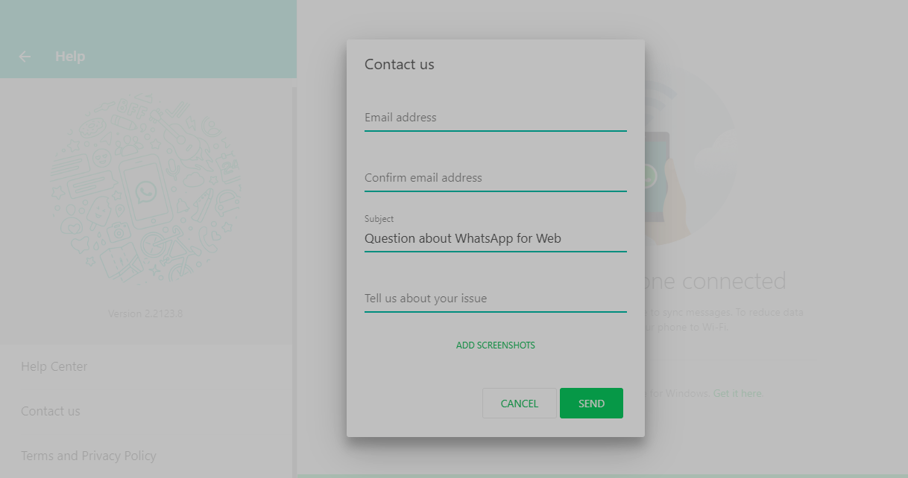

**Figure 6.** Help panel to gather follow-up studies

1. **Conclusions & Future directives**

In Conclusion, the users will find it more convenient to manage their status and see the views on the desktop. Another drawback is that if status is well-intentioned and you need to share it with somebody to must watch it you can share it with him instantly while working on Desktop PC or laptop. For future work we can also place add status button in the status section. Perhaps, this research paper leads to erase the limitations from the web-WhatsApp and complete the usability as a mobile app provides.